Team 4 - Capstone Game Dev

Island Song: Q3 Report

Spring 2026
Revised: 20 March 2026

Logan Faulstich
Steven LaGoy
Zack McGill
Harrison Niswander
Ricardo Saldana
Riley Tate

Table of Contents
- Introduction 3
  - Overview
  - Glossary
- Product Vision
  - Problem statement 4
  - Stakeholder descriptions
    - Key stakeholders 5
    - User summary 5
    - User environment 6
    - Operating Environment and Development Tools 6
    - User stories 7
  - Product overview
    - Gameplay 7
    - Major features 8
- Requirements Model
  - Functional requirements 9
  - Non-functional requirements 10
  - Accessibility 10
- Project Plan
  - Project management 11
  - Timeline 12
  - Deliverables
    - Q1 13
    - Q2 13
    - Q3 14
    - Q4 14
- Sprint Artifacts for Q3
  - Percussion Puzzle 14
  - Strings Puzzle 15
  - Color Mechanic 15
  - Music and Sound 15
  - Collectables 15
  - Challenges 15
  - Executable and Installer 15
  - Testing 16
  - Time Effort Log 17
- Risk Assessment
  - Scope assessment 17
  - Development priority 17
  - Data management 17
  - Learning approach 18
  - Time Constraints 18
  - Unique Implementation Styles 19
- Testing / Requirement Traceability Matrix 20
- Task List and Backlog 21

Introduction
Island Song is a free-to-play single-player puzzle and exploration game with an emphasis on music and color. Players solve music- and sound-based puzzles and challenges in a unique world themed around instrument families, bringing the enchanted Island of Song back to life by spreading music and color. Island Song features a unique, living open world with a playful atmosphere and many auditory and visual experiences to discover.

Glossary
POI – Point of Interest, any location in the Game World designed with a certain unique experience or user interaction in mind.
UI – User Interface, the buttons, prompts, text, and other visible components forming the interface between player and game.
HUD – Heads-Up Display, a persistent element of the UI which communicates details about the in-game player avatar or world to users.
FPS – Frames Per Second, a performance metric for the speed at which a game is running.
VCS – Version Control System, used to manage the shared codebase.
MVP – Minimum Viable Product, the subset of defined game features which sufficiently fulfills necessary functional and nonfunctional requirements.
Unreal Engine – An industry-standard game engine operated by Epic Games. Specifically, this project is built with Unreal Engine 5.
Player – Primary user who will interact with the UI and content in the game map.
Player Character – The character avatar who is directly controlled by the Player.
Camera – The location of the active camera determines the player’s perspective of the world. Usually, there is a single camera which follows the player.
Game Map – The space or world in which the player can explore and find interactable objects.
Map Area – Segmented areas of the map with unique environmental themes, instrumental melodies, and puzzles.
Puzzle – A large interactable system or set of systems in the Game World which can be completed in a developer-defined way. These may include several distinct levels or stages.

Glossary (cont.)
Challenge – An instance of a system (smaller than a puzzle) which has a predetermined condition to give the player a reward.
Currency – Any collectable item or category of items which can be obtained by the Player through performing certain actions, and which can be used to purchase or unlock additional content.
Actor – One instance of an object in the world which has a location and behavior.
Blueprint – A node-based scripting system provided within Unreal Engine to define object-oriented classes, actors, and objects.
NPC – Non-Player Characters with whom the player can speak or otherwise interact.
RTM – Requirements Traceability Matrix, a method of testing and tracking expected and actual behaviors for completed systems.

Product Vision

Problem Statement
Many modern games offer expansive, realistic worlds which showcase technical achievement but compromise on the charm of a curated, approachable, and whimsical world. With this game, Crustacean Works aims to realize a fuller potential of music and color in video storytelling. An emotional world will connect with many players and allow them to explore their own capacity for art as they restore vibrant life to a quiet and colorless world.

Stakeholder descriptions

Key Stakeholders
Project sponsor – Aga Pito Studios, LLC; Jared Lehman, Esq.
Faculty Advisor – Prof. Thomas Bolinger
Development Team:
- Steven LaGoy: Team lead, World Designer, Composer
- Zack McGill: Project Manager, Lead Architect
- Harrison Niswander: Treasurer, Art & Sound Designer
- Riley Tate: Recordkeeper, Lead Puzzle Designer
- Logan Faulstich: UI Designer
- Ricardo Saldana: Story Designer
Creative Collaborators:
At various stages of the project, students or freelancers in art or music were commissioned for certain assets, sound elements, or musical performances.
- Emma Lytle: Student collaborator designing Character and NPC models
* Listed roles do not indicate the full extent of a team member’s roles and contributions. For example, all members of the team were responsible for the design and implementation of at least one puzzle.

User summary
Target Audience: People familiar with casual video games, looking for a slow-paced immersive story, exploration, and an outlet for creative thought. (“Players”)
Play Testers: Ideally, play testers are members of the target audience. Play testers were asked to play a version of the game for some period of time, and their gameplay was observed or recorded for iterative analysis to improve game systems.

User environment
Target Platform:
Specification | Minimum | Recommended
OS | Windows 7 64-bit | Windows 11 64-bit
Processor | Intel Core i5 | Intel Core i5
Memory | 4 GB RAM | 8 GB RAM
Graphics | Intel HD 630 | GTX 750 Ti
Storage | 3 GB available space | 3 GB available space
Minimum and recommended specifications are likely to change throughout development.

Operating Environment and Development Tools
Game Engine: Unreal Engine 5
Programming Language: C++, Blueprints Visual Scripting
IDE: Microsoft Visual Studio, JetBrains Rider
Version Control: Perforce P4
Documentation: Microsoft SharePoint
Project Management: Jira
Communication: Microsoft Teams
Composition: MuseScore Studio 4 (w/ Muse Sounds DAWs)
Audio Editing: Audacity
Design Mockups: Canva
3D Modeling: Blender
Terrain Generation: QuadSpinner Gaea 2
Website Hosting: Google Cloud Run

User Stories
As a sponsor, I want to provide a challenging but approachable learning experience.
As a sponsor, I have a minimum viable product in mind and want to see it executed.
As a developer, I want to create a fun, cohesive, and complete game based on our scope.
As a developer, I want to take a game idea through the project development life cycle.
As an artist, I want the opportunity to create art that connects with the game’s tone.
As a player, I want to understand my goals and motivations within the game.
As a player, I want a relaxing but immersive gameplay experience.
As a gameplay tester, I want to share my thoughts on what could make the game better.

Product Overview

Gameplay
Core gameplay loop:
The primary game loop consists of exploration of an area of the game world, finding, understanding, and completing an interactive puzzle, restoring color to an area of the map, and progressing to newly opened areas.
Pillars of experience:
The pillars of gameplay experience define the most important factors in communicating the team’s vision to players. These factors will receive the most focus when applying unique themes to areas of the map, gameplay elements, et cetera.
- Exploration
  - Players should be rewarded for their adventure in new parts of the world. The scale and shape of the world should guide players’ decisions naturally towards exploration.
- Puzzles
  - Players want to feel competent when solving puzzles. This involves clear explanation of basic puzzle mechanics and then building on the player’s existing knowledge to create an engaging and challenging puzzle.

Pillars of experience (cont.)
- Music
  - Music is a key element of an immersive game world and further connects with puzzles in Island Song. Music should complement the themed areas of the map.
- Color
  - Color is another key element of the player’s influence in the game world. Intentional use of color will visually show the player’s completion of puzzles. See “Color Mechanic” in Q2 deliverables below.

Major features
These features are explored in terms of product goals in the Requirements Model section. They realize the Pillars of Experience by enumerating key details of player interaction with the game world, story, and mechanics.
- Player movement
- Non-linear island exploration
- Fixed map arrangement
- Unlockable areas
- Area theming
- Musically and visually integrated puzzle design
- Functional UI / HUD
- Multi-stage puzzle design
- Ambient and area-specific soundtracks
- Music cues and theming
- Color restoration mechanics
- Low-poly art style

Requirements Model

Functional Requirements
Functional requirements define the features and behaviors of the game.
- The game must include a main menu screen
  - Creative game logo design and team name / logo
  - “Start Game” should load the most recently played saved game
  - “Load Game” should allow selection of any saved game
  - “Create New Game” should create a new game and start the story
  - “Settings” should allow players to change their game settings
- During gameplay, players should be able to save their progress, adjust their settings, or leave the game to the menu or to their desktop
  - Settings should include audio volume, FOV, graphics quality
- The game should include several interactive, challenging, and unique puzzles
- Progress should be communicated to the player though an inventory, unlocking areas of the map, story progress, and other means
- Visual/Audio style should impart a unique and immersive look to the game
- The map must consist of 5 unique areas with 3 unique puzzles; completion of the game involves completing all implemented puzzles
- Map and area boundaries should be communicated clearly to the player
- Movement should involve using the mouse and WASD keys (or other key remaps)
- Completing the game should result in some amount of end-game content (special cutscene, customizable, or other unlock)

Non-functional Requirements
Non-functional requirements include qualities and aspects of the game.
- No more than 30 seconds should elapse between launching the game and being presented with the menu screen
- Loading a previously saved game from the menu should take less than 20 seconds
- Players should not experience a loading screen while in the game world
- Performance on target systems with recommended settings should remain at or above 60 FPS
- Noticeable “lag spikes” should be minimized between areas
- 1 hour of continuous, regular gameplay should be possible without experiencing game crashes
- Responsive elements of the world (puzzle elements, buttons, doors, characters) should visually respond to proper input within 0.5 seconds of interaction

Accessibility
To promote accessibility for many kinds of people, efforts will be made to provide settings or accommodations for people with limited mobility, sight, or hearing. This may include; colorblindness settings, high-contrast filters, audio narration, on-screen audio prompts / closed captions, support for multiple input devices, remappable controls, adjustable text size, adjustable control sensitivity, inverted view axes, in-game reminders for controls, and/or resizable UI. In the design of game elements and puzzles, thought toward accessibility will inform decisions, including minimizing quickly changing or flashing lights and colors, allowing players to choose their own pace for dialog and navigation, clarity and consistency in game text and descriptions, and clearly marking interactable objects visually.

Project Plan

Project management
The ~32 weeks during which this game will be developed are divided into 2 semesters and 4 quarters. Quarter 1 (Q1) and quarter 2 (Q2) fall during the Fall semester, with the end of Q1 corresponding to Fall midterms (17 October 2025) and the end of Q2 corresponding to Fall finals (14 Dec 2025). Quarter 3 (Q3) and quarter 4 (Q4) fall during the Spring semester, with the end of Q3 corresponding to Spring midterms (20 March 2026) and the end of Q4 corresponding to Spring finals (1 May 2026).
During each quarter, around four 2-week sprints are planned. Each sprint will begin with a Sprint Planning meeting to create, assign, and refine tasks for the next 2-week period. In the middle of every week, which is part of a sprint, a Scrum meeting will allow team members to share their progress, blockers, and goals with each other and with the faculty advisor.

Timeline
Quarter # | Sprint # | Sprint Start | Sprint End
1 | 0 | 22 Aug 2025 | 07 Sep 2025
1 | 1 | 08 Sep 2025 | 21 Sep 2025
1 | 2 | 22 Sep 2025 | 05 Oct 2025
1 | 3 | 06 Oct 2025 | 17 Oct 2025
FALL RECESS | FALL RECESS | 18 Oct 2025 | 21 Oct 2025
2 | 4 | 22 Oct 2025 | 02 Nov 2025
2 | 5 | 03 Nov 2025 | 16 Nov 2025
2 | 6 | 17 Nov 2025 | 25 Nov 2025
THANKSGIVING | THANKSGIVING | 26 Nov 2025 | 30 Nov 2025
2 | 7 | 01 Dec 2025 | 14 Dec 2025
FALL FINALS | FALL FINALS | 15 Dec 2025 | 21 Dec 2025
WINTER BREAK | WINTER BREAK | 22 Dec 2025 | 11 Jan 2026
3 | 8 | 12 Jan 2026 | 25 Jan 2026
3 | 9 | 26 Jan 2026 | 08 Feb 2026
3 | 10 | 09 Feb 2026 | 22 Feb 2026
3 | 11 | 23 Feb 2026 | 08 Mar 2026
SPRING RECESS | SPRING RECESS | 09 Mar 2026 | 15 Mar 2026
4 | 12 | 16 Mar 2026 | 29 Mar 2026
4 | 13 | 30 Mar 2026 | 12 Apr 2026
4 | 14 | 13 Apr 2026 | 26 Apr 2026
4 | 15 | 27 Apr 2026 | 03 May 2026
SPRING FINALS | SPRING FINALS | 04 May 2026 | 10 May 2026

Deliverables
Each quarter contains an important deliverable goal.
Quarter | Deliverable
1 | Game map, player movement demo, game story bible
2 | MVP for 1 interactive puzzle, color mechanic demo
3 | MVP for 3 interactive puzzles, finalized music & assets
4 | Testing reports, completed game, hosted installer

Q1
Game map: Complete an explorable iteration of the game map, with some assets populating 6 distinct areas. Record a brief tour of the game world through each area.
Player movement demo: Demonstrate player movement, including camera movement, walking, running, jumping. This demo can be included in the world tour described above.
Game story bible: Document in a “story bible” the story of the game to serve as a guide and inspiration for story and thematic elements.

Q2
MVP for 1 interactive puzzle: Develop and test one interactive puzzle for one of the 5 themed areas. Players should be able to understand, interpret, and solve a challenge which connects to the game world and an instrument's family theme.
Finalize map textures: Determine the textures to be used in populating the game map, including terrain such as grass, dirt, stone, etc. A balance of low-poly style and texture detail is preferable: as art is a secondary or tertiary focus of this project, the workflow for textures, models, and other artistic assets should be minimally detracting from other tasks.
Color mechanic demo: Demonstrate the color mechanic, including the player spreading color in a radius around them, in footsteps, and by interacting with the world (I.E. completing a puzzle).
Implement UI menus: Design UI menus such as main menu and options/settings/pause menu and connecting options to their corresponding task. Such as starting the game when clicking play or quitting when clicking quit.
Finalize character model: Search for functional character model that can be animated or has preset animations that function for our game. Reach out to Andres Montenegro or do some outreach to find potential modeler.
Create save states: Learn and master save states in UE5 and implement for saving character states such as island progress and inventory.
Finalize group logo options: Create multiple variations of logo for group and determine what we want to finalize and integrate into our splash screen.

Q3
MVP for 3 interactive puzzles: As in Q2, develop and test a total of at least 3 interactive puzzles in 3 different themed areas (including the puzzle from Q2). Finalized music & assets: Have the final assets and music placed properly into the game world. This includes soundtrack, audio elements, world features, UI elements, and game art.

Q4
Testing reports: Conduct user testing and prepare a report on how user gameplay feedback informed development decisions and feature iterations.
Completed game: Deliver an MVP for the game as a whole, fulfilling all outlined necessary requirements and key user stories.
Hosted installer: Provide an installer for the game possibly hosted on a site like Steam or Itch.io. Provide continued personal or institutional access to the game for a minimum number of years following Spring 2025.

Sprint Artifacts for Q3
During this semester, the team was split into three pairs to complete tasks. Each of the pairs worked for three sprints (6 weeks) to create a puzzle and were then assigned other tasks to improve gameplay experience and polish.
Percussion Puzzle MVP Completed: The team of Ricardo and Logan completed the Percussion Puzzle. This puzzle consists of three levels of sliding puzzles. The first level is a 2x2 grid, the second level has a 3x3 grid, and the third level is 4x4 grid. These puzzles are spread throughout the percussion area for the player to find.
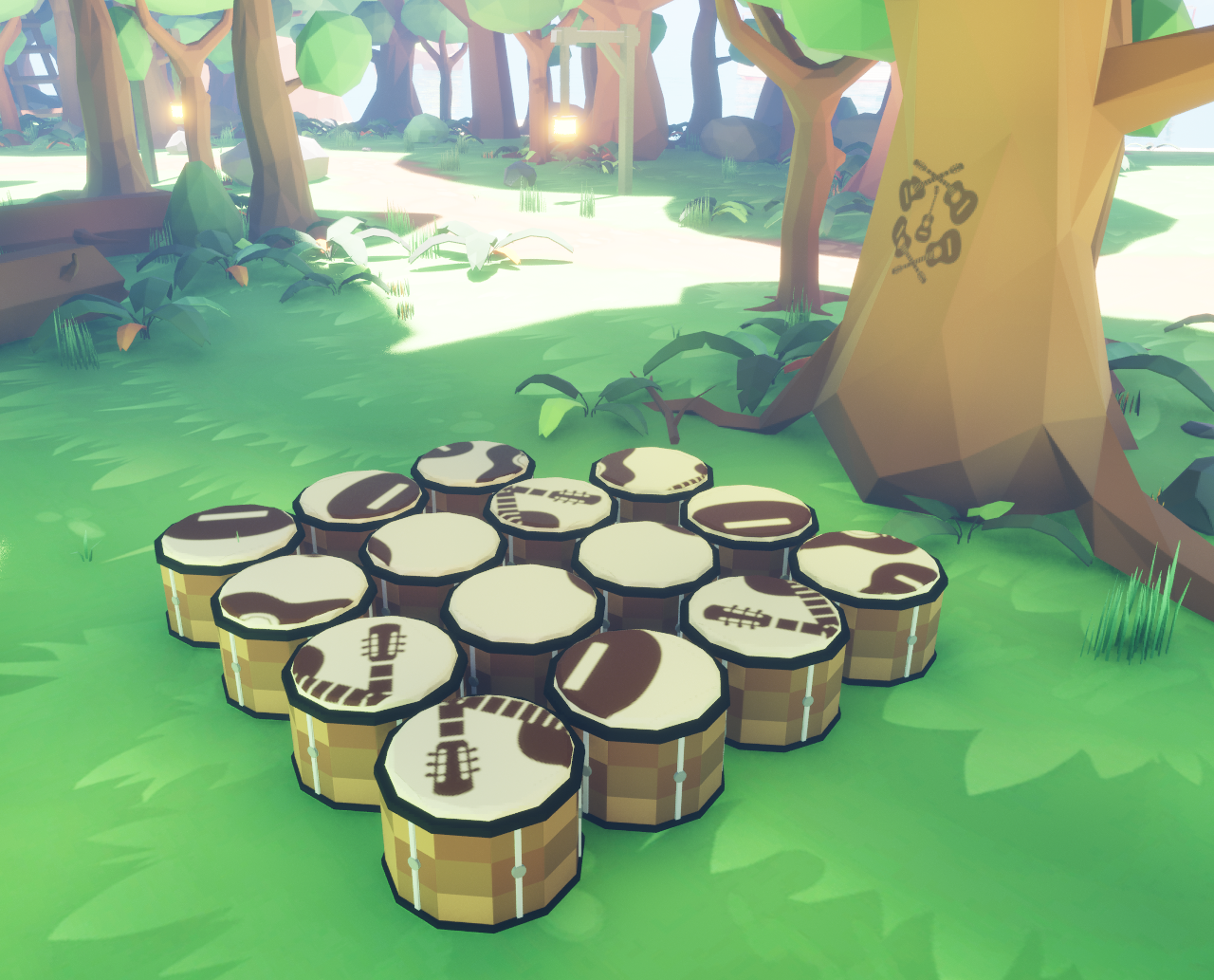
Strings Puzzle MVP Completed: The team of Riley and Harrison completed the Strings Puzzle. In this puzzle, there are 5 vines of different lengths that need to be placed on 10 pegs, with no vines overlapping. Since each vine is a different length, it can fit only between certain pegs. These rules together ensure there is only one valid solution.
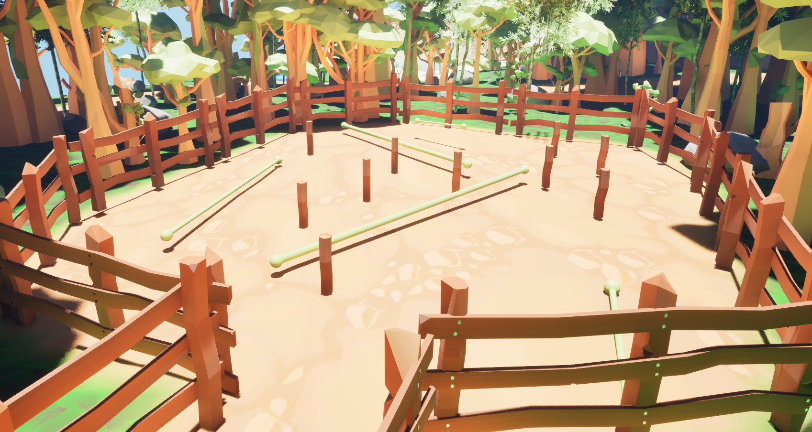
Color Mechanic: Zack improved the behavior of the color mechanic: one area of the map may now have its color restored or removed using controllable flags; a radial color animation which is used whenever an area’s color is restored; and certain objects in the world may individually have their color overridden (such as crystals in the Keys Cave).
Music and Sound: Steven created three original music tracks: “Crystal Clear” for the keys area, “Tonewood” for the strings area, and “Roots Rhythm” for the percussion area. Ricardo added ambient sounds throughout the world, including wave and wind sounds.
Collectables: Steven created collectable music notes scattered throughout the world. These are treated as a currency and may be used to unlock doors between areas. The HUD also now displays number of collected notes.
Challenges: Steven created three parkour challenges, two racing challenges, and a goal challenge. Parkour challenges involve controlling the player to reach a collectable, at the risk of falling and being sent back to a checkpoint. Racing challenges involve moving from a starting zone, through some number of checkpoints, to an ending zone, within a certain time limit. Goal challenges involve moving a physics actor into a predefined goal area. Each challenge grants notes to the player for completion.
Executable and Installer: Zack packaged the game into a portable executable for Windows machines, which can be downloaded and played by anyone with the minimum system. This involves creating a stable version of the game (with no editor errors or significant bugs) and storing that with the VCS. There is also a standalone installer which involves a downloader wizard designed to make the process of game installation easy for players.
Testing: The team began regular testing during this half semester, in two primary forms. Firstly, internal testing was conducted using an RTM and involved creating testing rows of preconditions, player actions, expected results, and actual results. As a rule, the team member who implemented a system may write tests, but the final pass/fail observation must be performed by another member of the team. Secondly, external testing during this half semester consisted of closed alpha testing, in which a small number of play testers were invited to explore any area of the game map while being observed by a team member. The observer noted any significant suggestions to improve the game experience and shared these with the team.

Time Effort Log
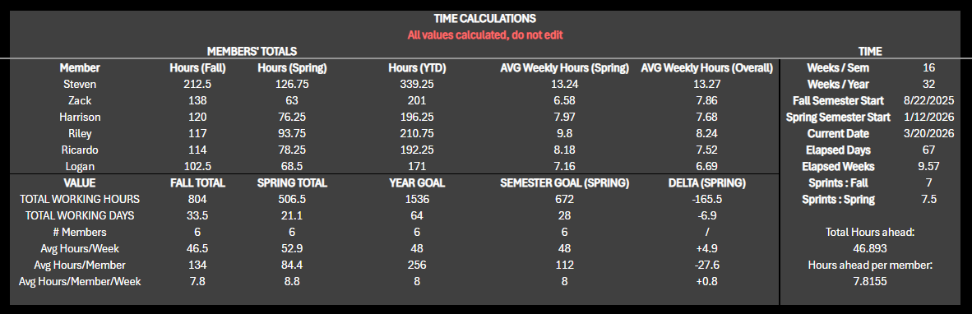
This time effort log summary shows the average weekly hours spent by each team member compared to expected, as of 20 March 2026. On this date, the team had contributed an excess of nearly 47 hours in total compared to minimum expectations, representing 85% of the total time budget for the 2-semester capstone course.

Risk Assessment

Scope assessment
This project will span two semesters between Fall 2025 and Spring 2026, a total of about 32 weeks. This involves designing, developing, testing, and revising an idea from concept start to end product. It will be necessary to continuously evaluate the scope of the project to ensure that it can be realistically developed by this team in this span of time. The risk of the project becoming too expansive in its goals or features is called “scope creep” and must be avoided by deliberately focusing on the minimum viable product (MVP). The goal of the team and its leadership is to promise little and deliver much, for the benefit of stakeholders and the team’s own well-being and educational opportunities. Mitigation will also involve comparing the project’s current stage of development to an expected timeline of deliverables based on research in similar game projects and guided by experienced advisors and stakeholders. The team’s “velocity” will determine which of the stretch features will be feasible while meeting applicable deadlines.
To increase the amount of content in the world without creating an exploding scope, the idea of Challenges was created. These have made rapidly adding new unique but engaging content much more feasible while still allowing Puzzles to take the center spotlight. Additionally, defining pairs within the team has allowed focus to be split between several requirements at one time. This has improved the velocity of the team as executive privilege was able to be cast to one or two developers where before such design decisions required the entire team.

Development priority
As this game idea contains a heavy emphasis on music arts, audio elements and the soundtrack will necessarily require extra time and effort compared to other game projects with similar scopes. As the primary focus of the project itself is on Computer Science, and as the team members are more experienced with and oriented towards other aspects of game development, it is paramount that the effort spent towards writing and performing music for the game does not overshadow the development of game functionality. To mitigate this risk, other choices about the art direction were made, including selecting a “low-poly” art style rather than a more realistic, art-intensive style. Additionally, collaborators outside of the CS capstone with an interest in music were commissioned to do some work on creating art and assets for the game world, rather than team members creating those assets themselves.

Data management
Managing internal project data is an important factor in the development of a game project. Not only will the team regularly access and modify large files containing code and asset information, which itself requires special technology and approaches to manage, but some data may be necessary to keep secure or confidential. As for the first of these concerns, VCS provides a solution. Using a specially licensed form of Perforce P4 Version Control, developers have been able to reliably share large engine files, with features like locking, stream management, and rollback minimizing file conflicts and breaking changes. The second concern has been most applicable to the testing phase of development, where gameplay testers voluntarily provided their time and information to play the game and give feedback. Keeping this data secure and managing potentially sensitive information was intensively considered before starting user testing. Accepted best practices for data security in HCI studies have informed the team at this stage, and explicit explanation for how data is used and play tester consent has been present in every playtesting session.

Learning approach
As team members are primarily learners, the foremost goal of this project is to provide experience and education to each team member. Every member of the team has used technologies new to them and has used familiar technologies in new ways. To mitigate the risk that learning and applying these new technologies and practices proves too daunting, team members have, as much as possible, shared their learning experiences with other members of the group to enable everyone to learn from one another. Existing tutorials, guides, and documentation have proven indispensable for the learning process. Learning was prioritized before development tasks, so that team members could overcome these challenges before implementing new features.

Time Constraints
With the project being allotted two semesters for entire implementation from concept to delivery, the team has been constantly aware of these strict time constraints. To meet our MVP on pace, we have determined that an Agile approach is best with eight story points per group member delegated each week. Each story point is not a fixed amount of time but rather represents one eighth the amount of work expected from each member each week. In biweekly Sprint planning meetings, new tasks have been discussed with all team members and assigned a number of story points. At weekly Scrum meetings, the assigned tasks have been reevaluated for their trajectory, sometimes revealing over- or under-estimation. In some cases, tasks have required more time than expected, cascading dependent tasks into later Sprints. To offset this, Scrum meetings serve a dual purpose of communicating blockers and personal velocity, allowing team members with greater velocity to aid other members with issues and catching up.

Unique Implementation Styles
As each member of the team has a different development history and uses different tools, tutorials, and other resources, there have been instances in which two or more members of the team implement similar solutions to emergent problems in different ways. To minimize the risk of redundant gameplay systems, inefficient designs, or cryptic blueprint graphs, team members have been encouraged to produce supplementary documentation which may easily be referenced by other team members. This provides a route for consistency when designing and implementing solutions in the game engine.

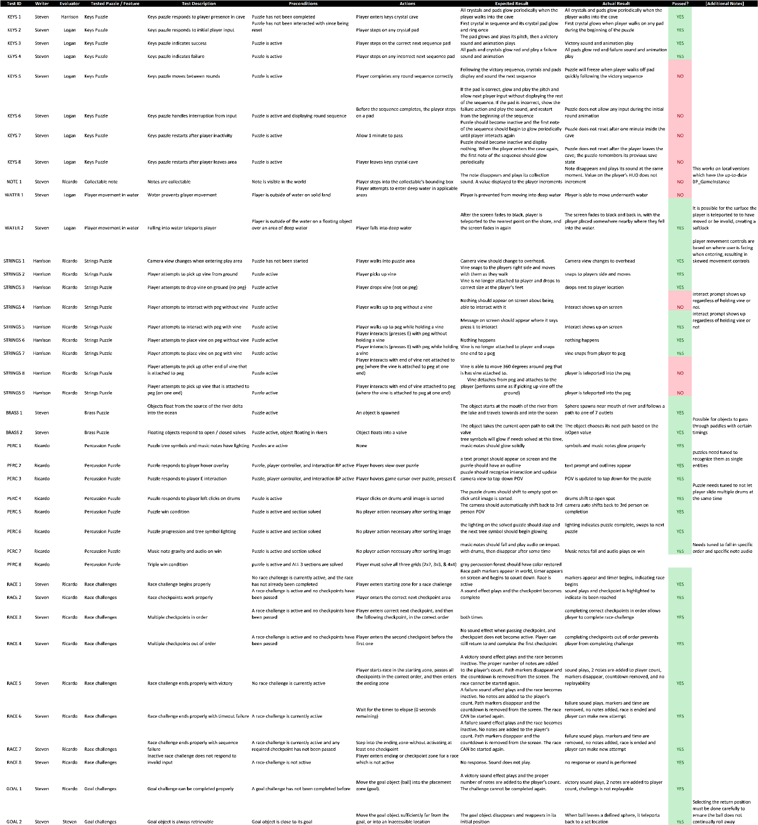
Testing / Requirement Traceability Matrix

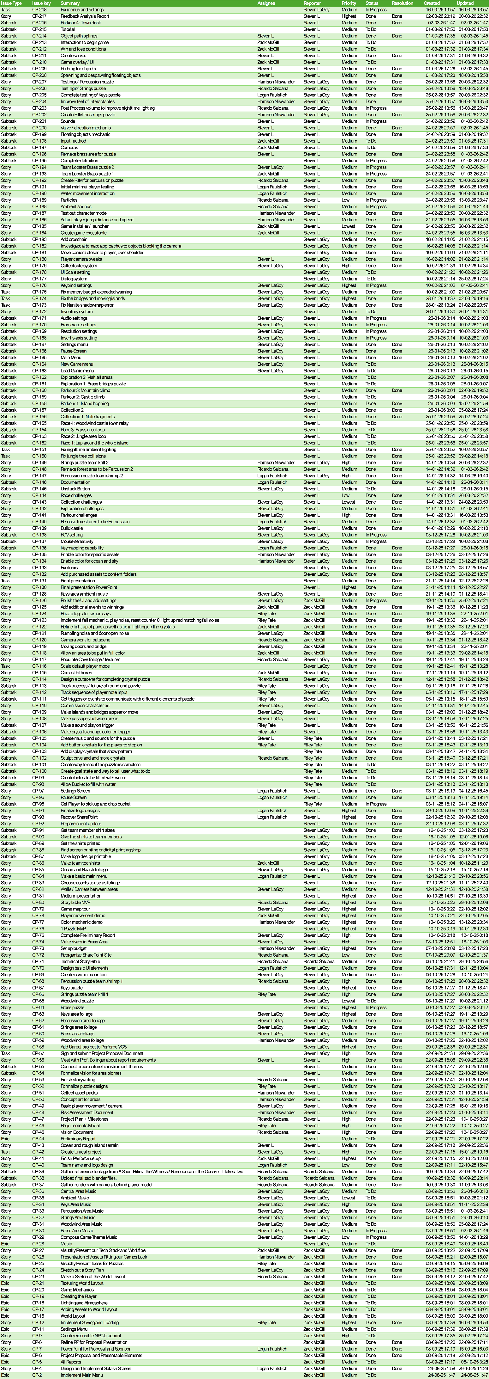
Task List and Backlog

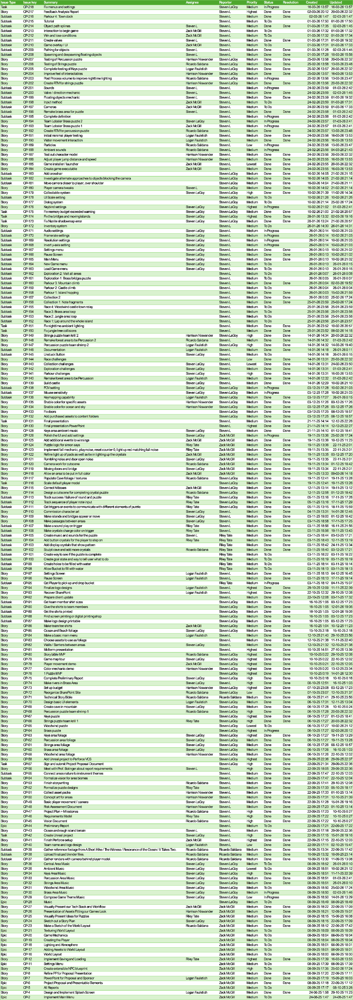
Task List and Backlog (cont.)

